35.35: a) To have a strong reflection, constructive interference is desired. One part of the light undergoes a half-cycle phase shift, so:

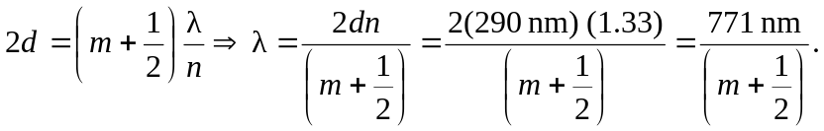 For an integer value of zero, the wavelength is not visible (infrared) but for 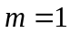, the wavelength is 514 nm, which is green.
b) When the wall thickness is 340 nm, the first visible constructive interference
occurs again for 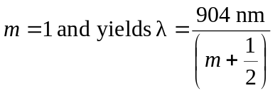= 603 nm, which is orange.

